Direct Deposit Authorization Form
Please print and complete ALL the information below.

Name: ________________________________________________________________
Address: _______________________________________________________________
City: ______________________ State: _______________ Zip: ____________________

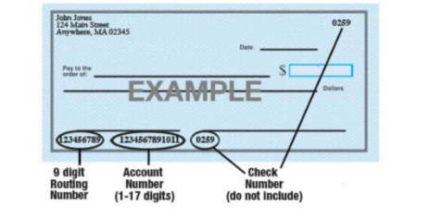
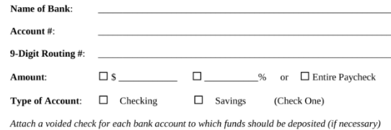
Griffin Contracting, Inc is hereby authorized to directly deposit my pay to the account listed above. This authorization will remain in effect until I modify or cancel it in writing.

EMPLOYEE SIGNATURE: _________________________________________________
DATE: ______________________
NOTE: YOUR FIRST CHECK WILL BE A PAPER CHECK. IT TAKES ONE PAYROLL CYCLE TO SET UP DIRECT DEPOSIT ACCOUNT.

